**Computer**

**FUNCTION**

BASIC COMPUTER USAGE

**OBJECTIVES FOR TODAY**

# ✓ The 4 function of a computer ✓ Computer hardware ✓ How Computer Operate

**Software**

ENGAGE

5

MIN

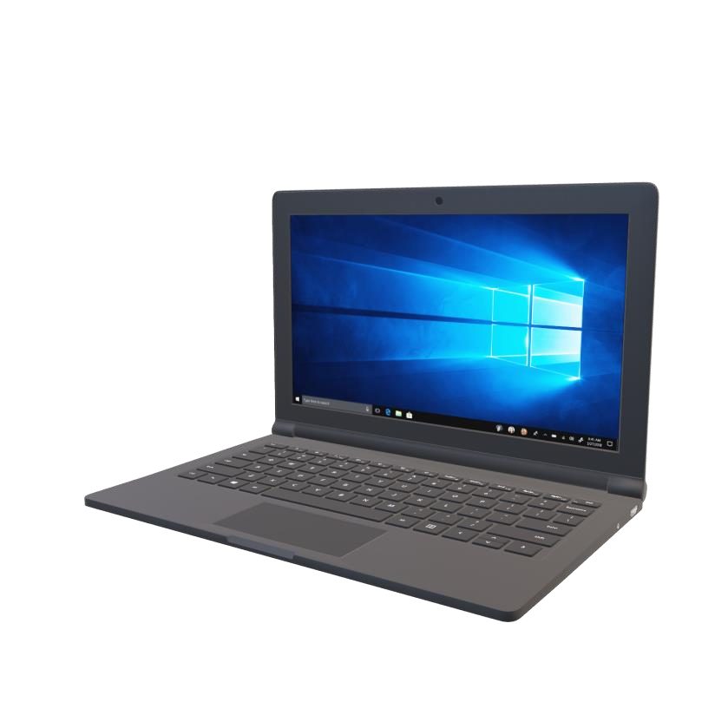

**Computer consist of ……..**

**Hardware**

Physical components, like monitor,

system unit, mouse, keyboard…

Set of instructions that tell the

computer what to do and how to do it.

(

)

Operating system, applications

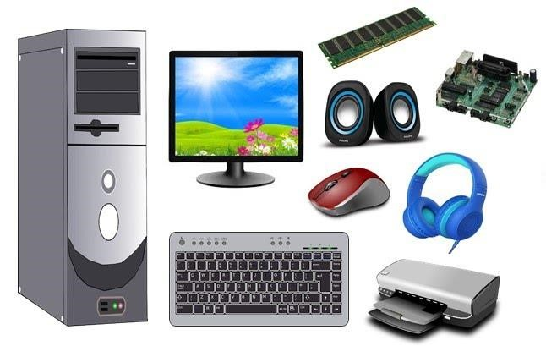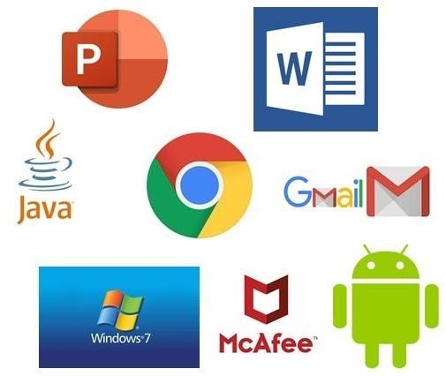

WATCH & THINK



10

MIN

Watch the video to understand

**hardware**

and

**software**

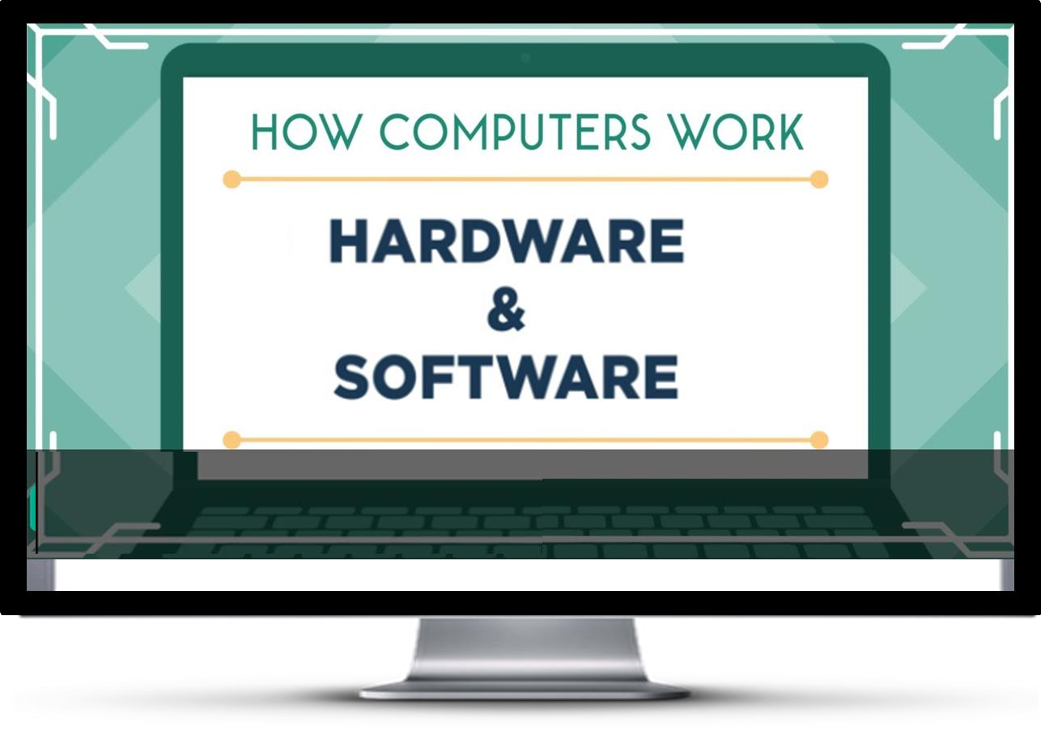

[**Click M**](https://youtu.be/VzVSt6jxiqw)

[**e**](https://youtu.be/VzVSt6jxiqw)

EXPLORE

5 MIN  **WHAT IS …?**



**Output**



WATCH & THINK



10

MIN

Watch the video and answer the questions



Activity **Hardware Components**

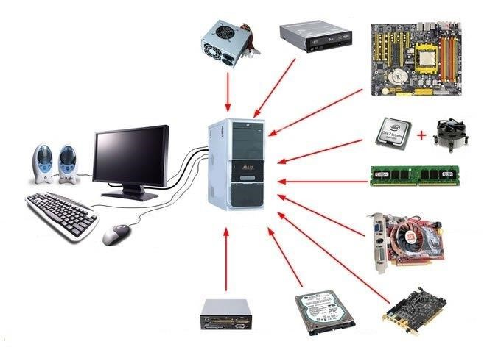

?

?

?

?

?

**?**

?

?

?

?

?

?

?

?

?



5

MIN

 EXPLAN **Hardware Components**



Speaker

Monitor

Keyboard

Mouse

Case

Power Supply

DVD Rom

Mainboard

CPU

CPU Fan

RAM

VGA Card

Sound Card

Hard disk

Reader

-

all

-

in

-

one Internal

**Desktop hardware**

5

MIN

EXPLAN

 **Computer Basic Operations**

10 MIN

Computer accept data from an *Input device* and *processes* into useful information which is display on it *Output device*. These tasks are all related to the four basic computer operations:

* **Data Input** (Use Input device)

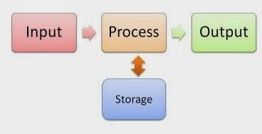

* **Data Processing** (Use processor / CPU)
* **Output information** (Use Output device)
* **Storage/Memory** (RAM/ Storage device)

10



**CPU Memory , Input & Output**

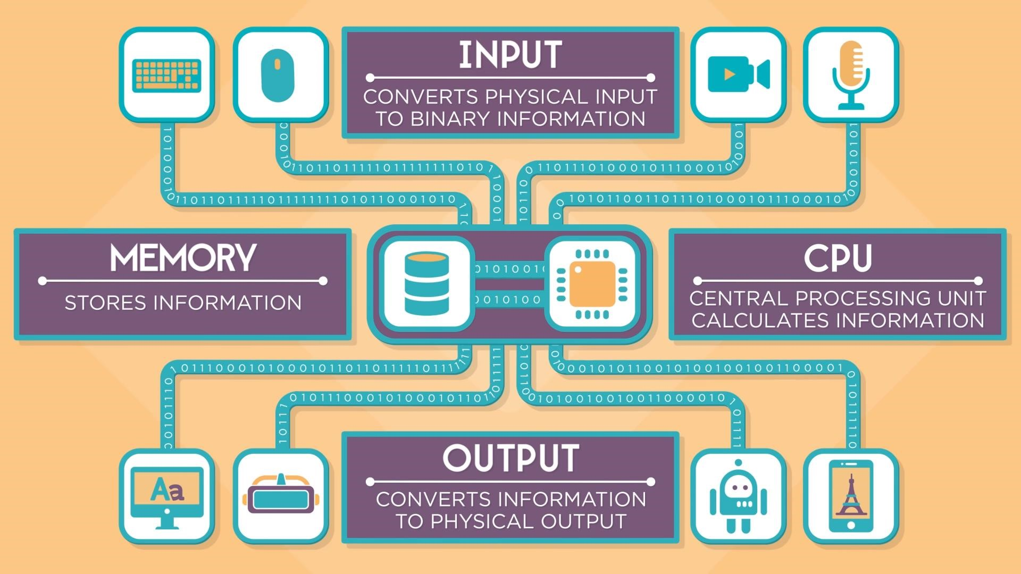

## GAME Games Find Input and Storage device



INPUT

device

Remote Control

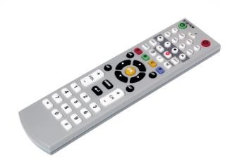

Web

cam

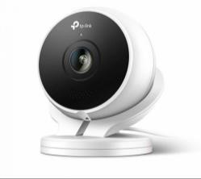

Scanner

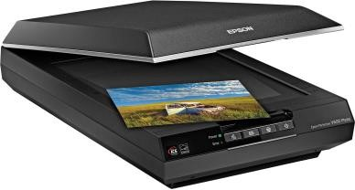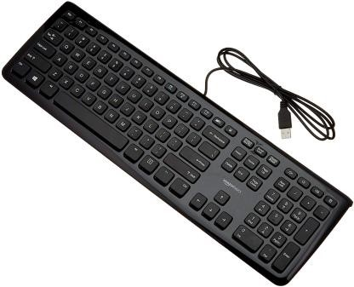

Keyboard

Microphone/Mic

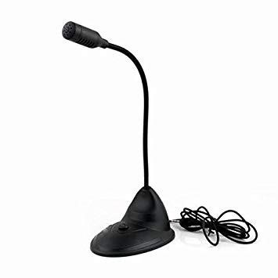

Mouse

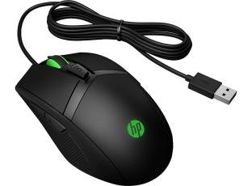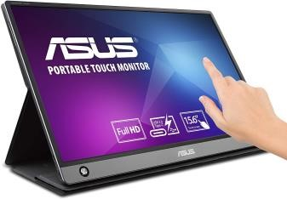

Touch screen



Storage

device

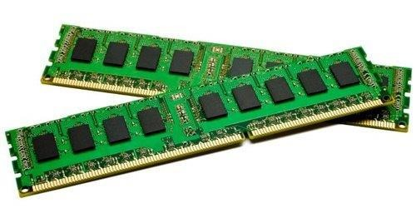

RAM

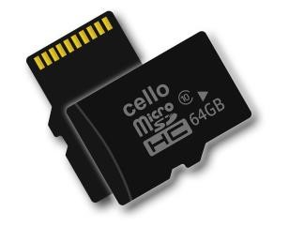

Memory card

Hard

disk

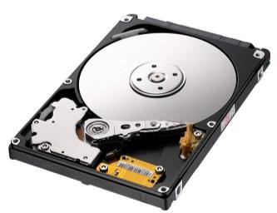

External HDD

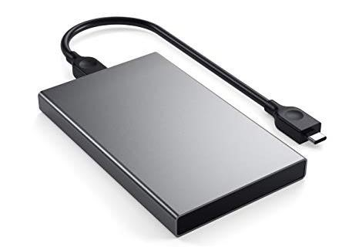

USB

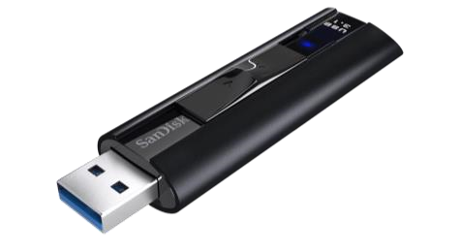

Tape media

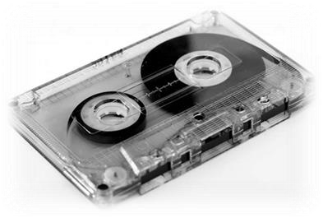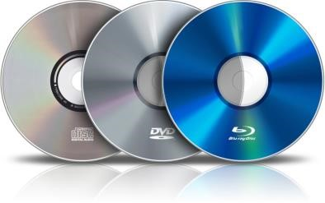

CD / DVD

SSD M

-

2

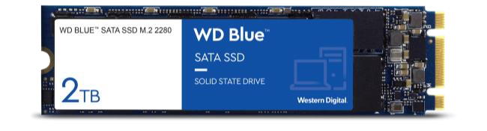

MIN

10

**Input device** is any hardware device that *sends data to a computer*, allowing you to interact with and control it.



INPUT

device

Remote Control

Mouse

Web

cam

Scanner

Microphone/Mic

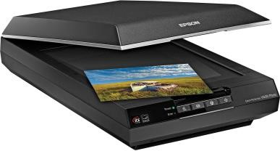

Keyboard



Touch screen

**Output** is anything that *comes out of a computer*. *Output devices* can be display screens, loudspeakers, printers and etc.



Output

device

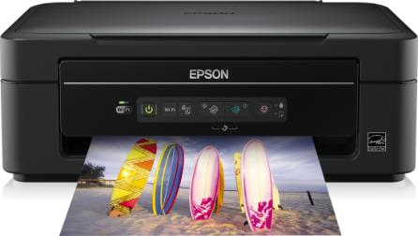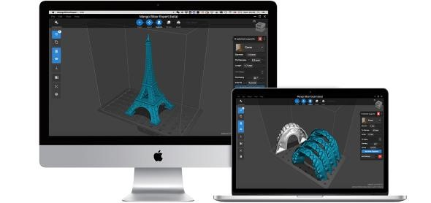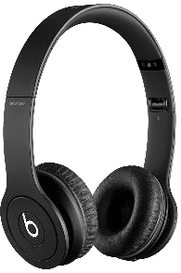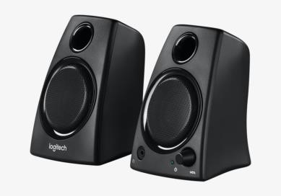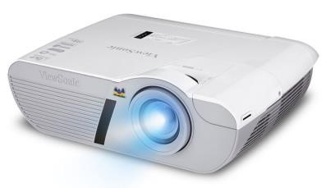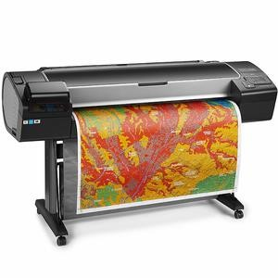

Headset

Speaker

Printer

Display screen/Monitor

Projector

Plotter

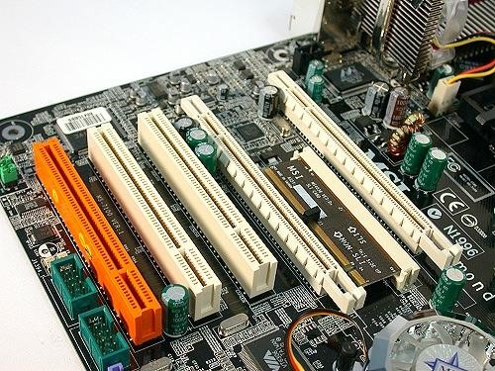**Processing devices** are used in processing the data, using the program instructions. They perform *different calculations and also control the hardware devices*.

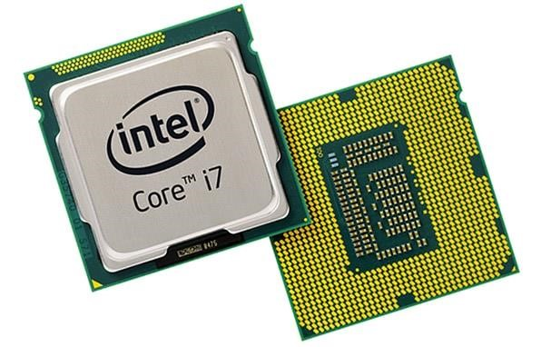

Mother

board

Expansion slots

RAM

**CPU/Processor**

Network

card

Sound card



Processing

device

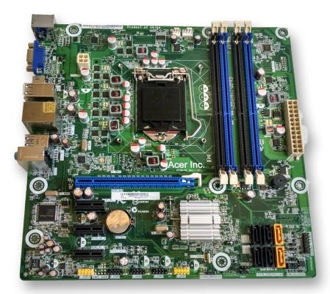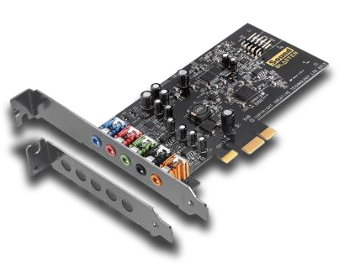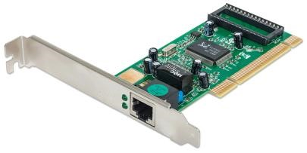

**Storage device** include any device which will store data until is needed for processing. This can include temporary and long-term storage devices.

### SSD M-2



Storage

device

RAM

Tape media

External HDD

Memory card

USB

Hard

disk

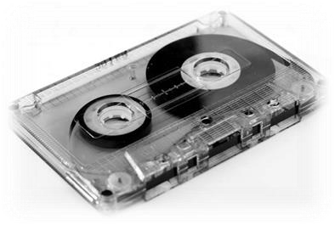

CD / DVD



**Look at the picture.**

**Choose Input and Output devices!**

